Our Savior’s Lutheran Church.

Order of Service – Vespers LSB 229

April 1st, 2020

Lent V

Stand

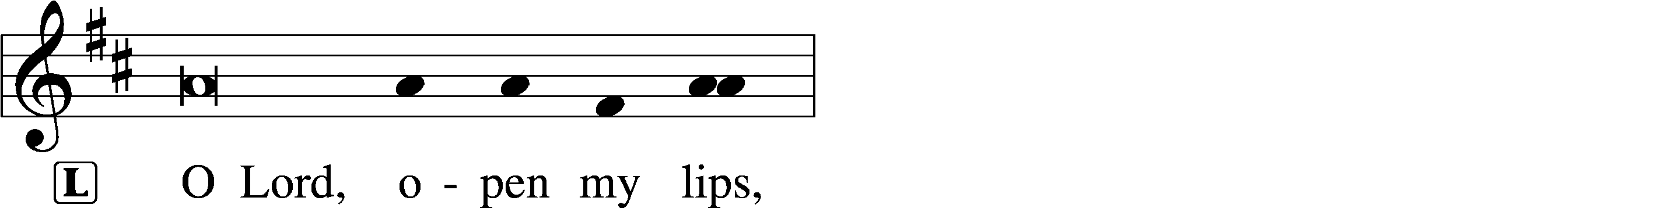
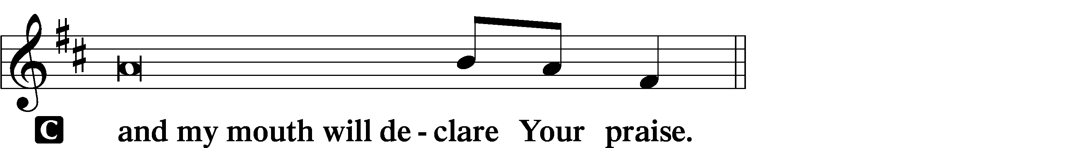

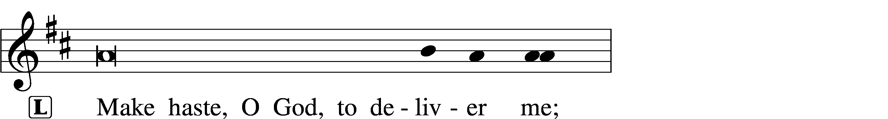
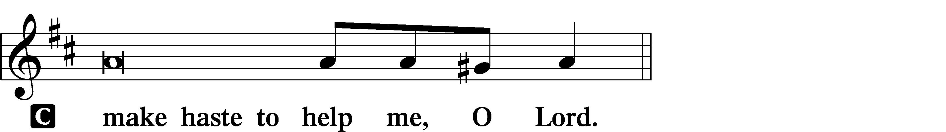

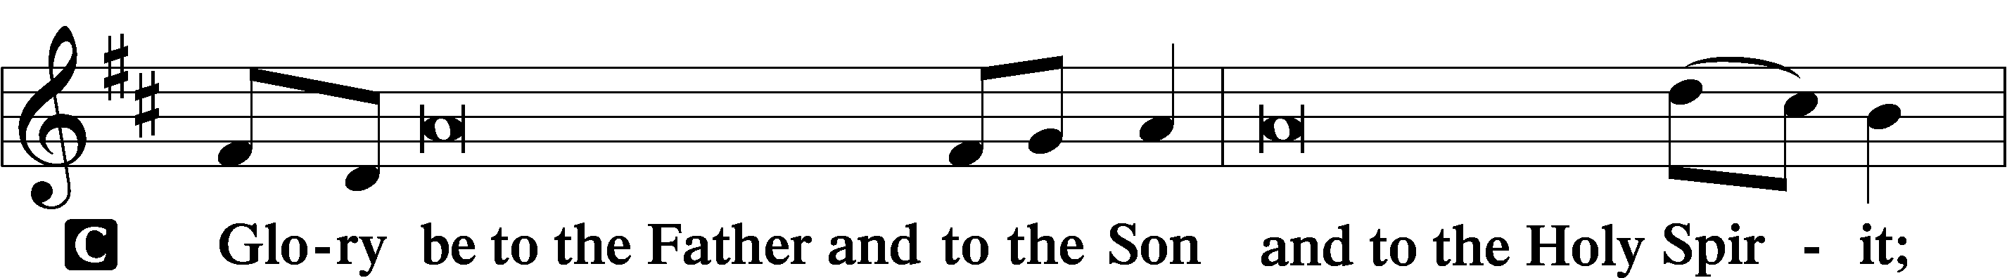
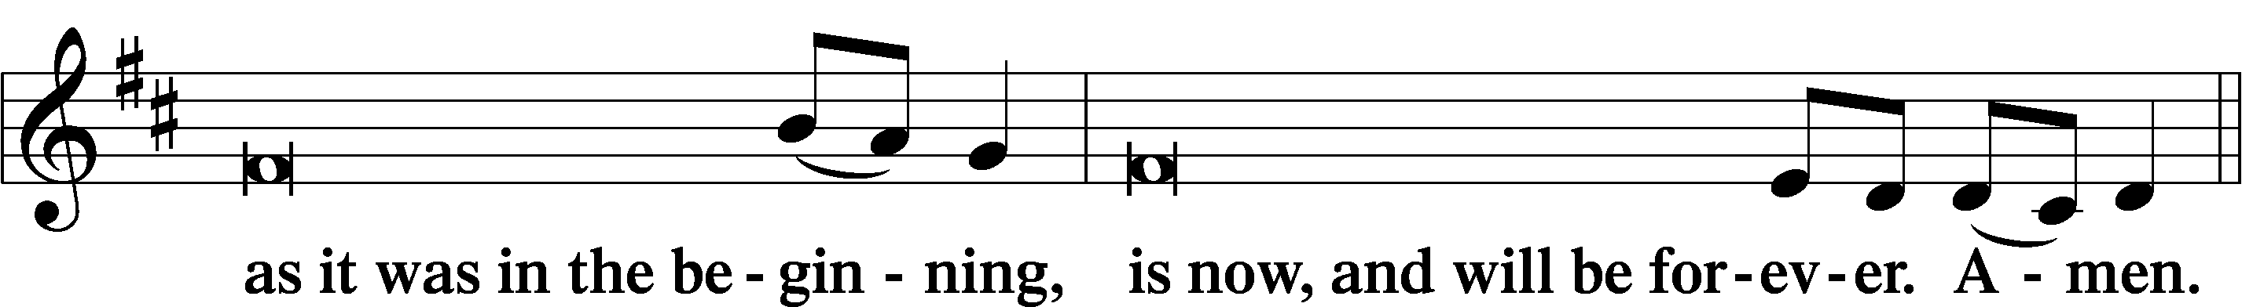
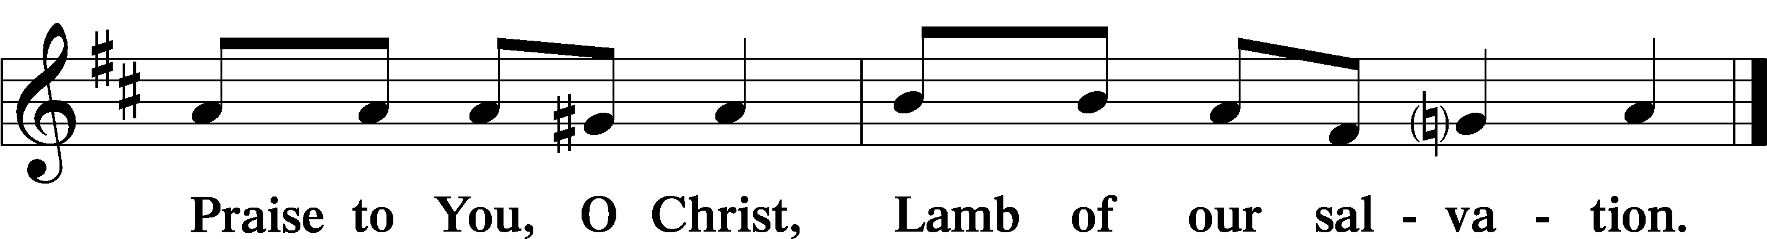

Psalmody

Psalm Psalm 43
Send Out Your Light and Your Truth
¹Vindicate me, O God, and defend my cause
against an ungodly people,
from the deceitful and unjust man
deliver me!
²For you are the God in whom I take refuge;
why have you rejected me?
Why do I go about mourning
because of the oppression of the enemy?
³Send out your light and your truth;
let them lead me;
let them bring me to your holy hill
and to your dwelling!
⁴Then I will go to the altar of God,
to God my exceeding joy,
and I will praise you with the lyre,
O God, my God.
⁵Why are you cast down, O my soul,
and why are you in turmoil within me?
Hope in God; for I shall again praise him,
my salvation and my God.

Sit

Office Hymn: 547 The Lamb
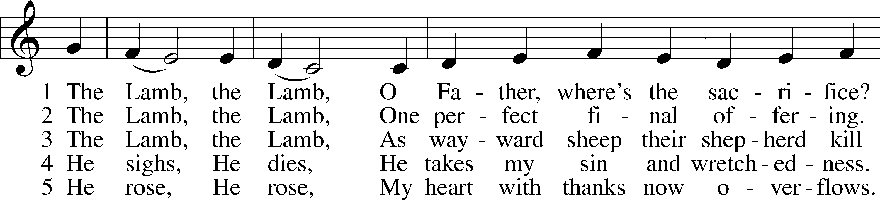
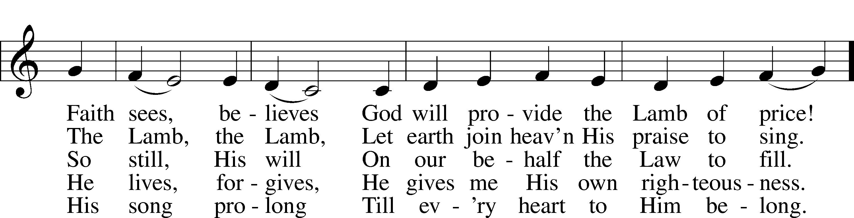
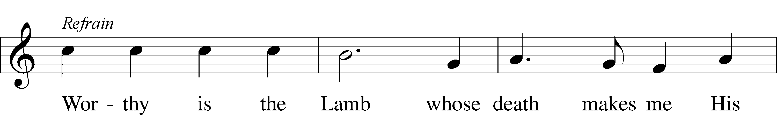
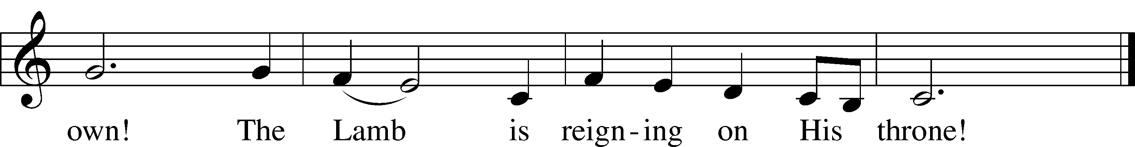
Text and tune: © 1987 and 1997 MorningStar Music Publishers. Used by permission: LSB Hymn License no. 110000483

Reading

Holy Gospel Mark 14:1–2, 53–65
The Plot to Kill Jesus
¹It was now two days before the Passover and the Feast of Unleavened Bread. And the chief priests and the scribes were seeking how to arrest him by stealth and kill him, ²for they said, “Not during the feast, lest there be an uproar from the people.”
Jesus Before the Council
⁵³And they led Jesus to the high priest. And all the chief priests and the elders and the scribes came together. ⁵⁴And Peter had followed him at a distance, right into the courtyard of the high priest. And he was sitting with the guards and warming himself at the fire. ⁵⁵Now the chief priests and the whole Council were seeking testimony against Jesus to put him to death, but they found none. ⁵⁶For many bore false witness against him, but their testimony did not agree. ⁵⁷And some stood up and bore false witness against him, saying, ⁵⁸“We heard him say, ‘I will destroy this temple that is made with hands, and in three days I will build another, not made with hands.’” ⁵⁹Yet even about this their testimony did not agree. ⁶⁰And the high priest stood up in the midst and asked Jesus, “Have you no answer to make? What is it that these men testify against you?” ⁶¹But he remained silent and made no answer. Again the high priest asked him, “Are you the Christ, the Son of the Blessed?” ⁶²And Jesus said, “I am, and you will see the Son of Man seated at the right hand of Power, and coming with the clouds of heaven.” ⁶³And the high priest tore his garments and said, “What further witnesses do we need? ⁶⁴You have heard his blasphemy. What is your decision?” And they all condemned him as deserving death. ⁶⁵And some began to spit on him and to cover his face and to strike him, saying to him, “Prophesy!” And the guards received him with blows.

Responsory (Lent) LSB 231
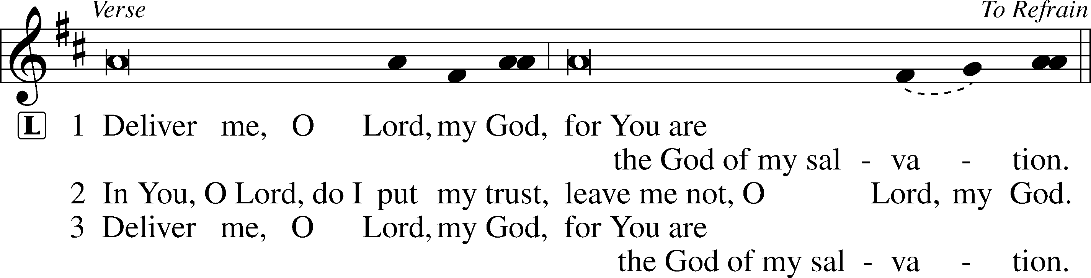
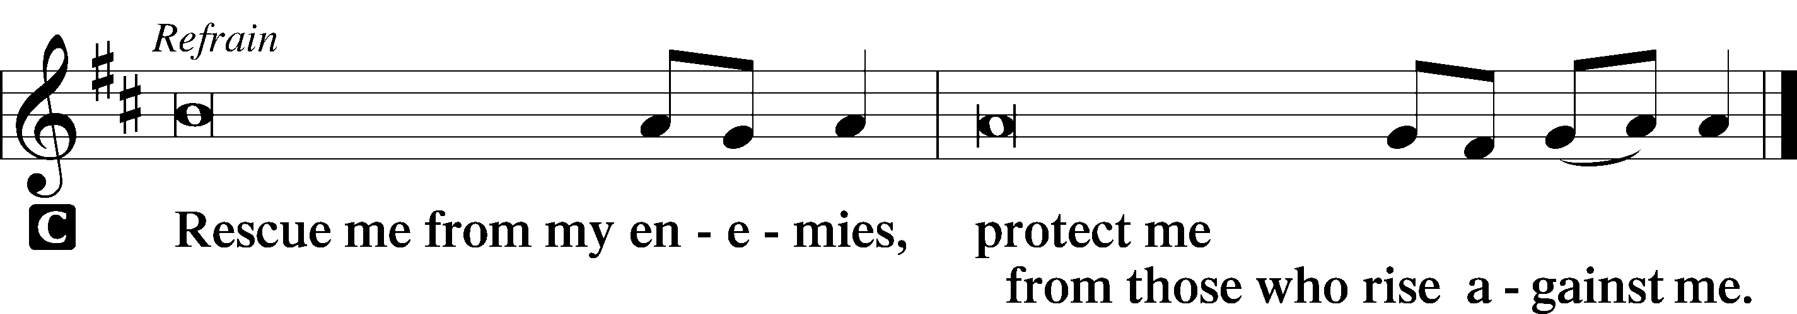

Sermon

Canticle
Stand

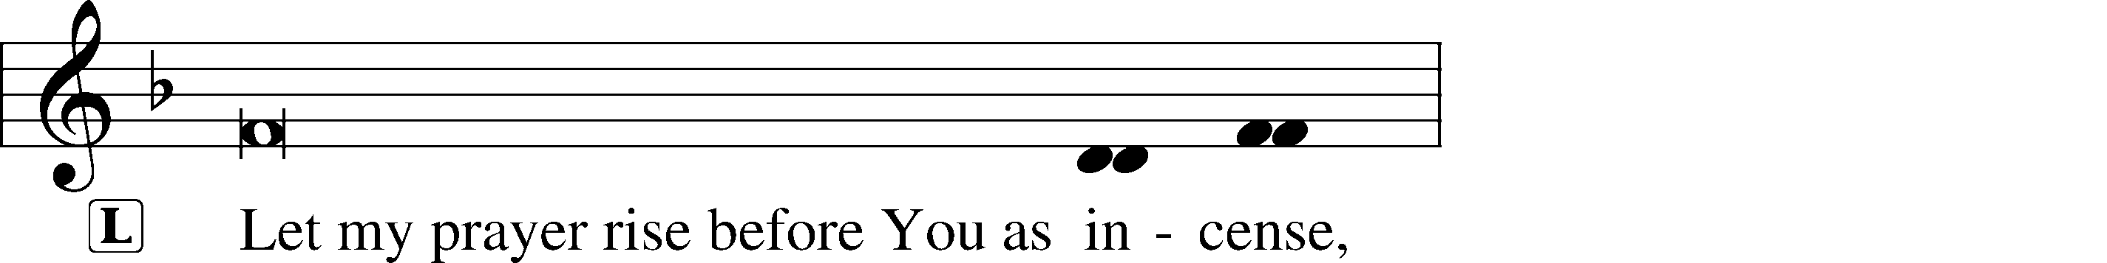
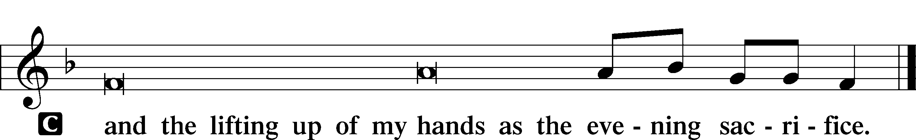

Magnificat LSB 231
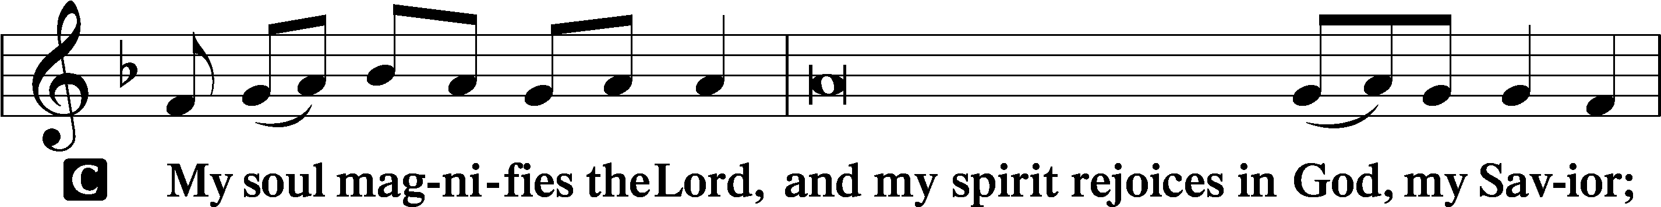
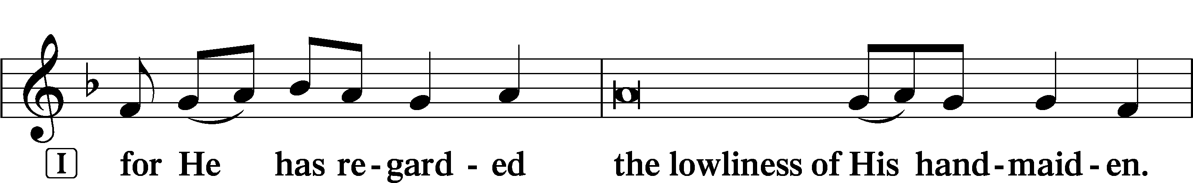
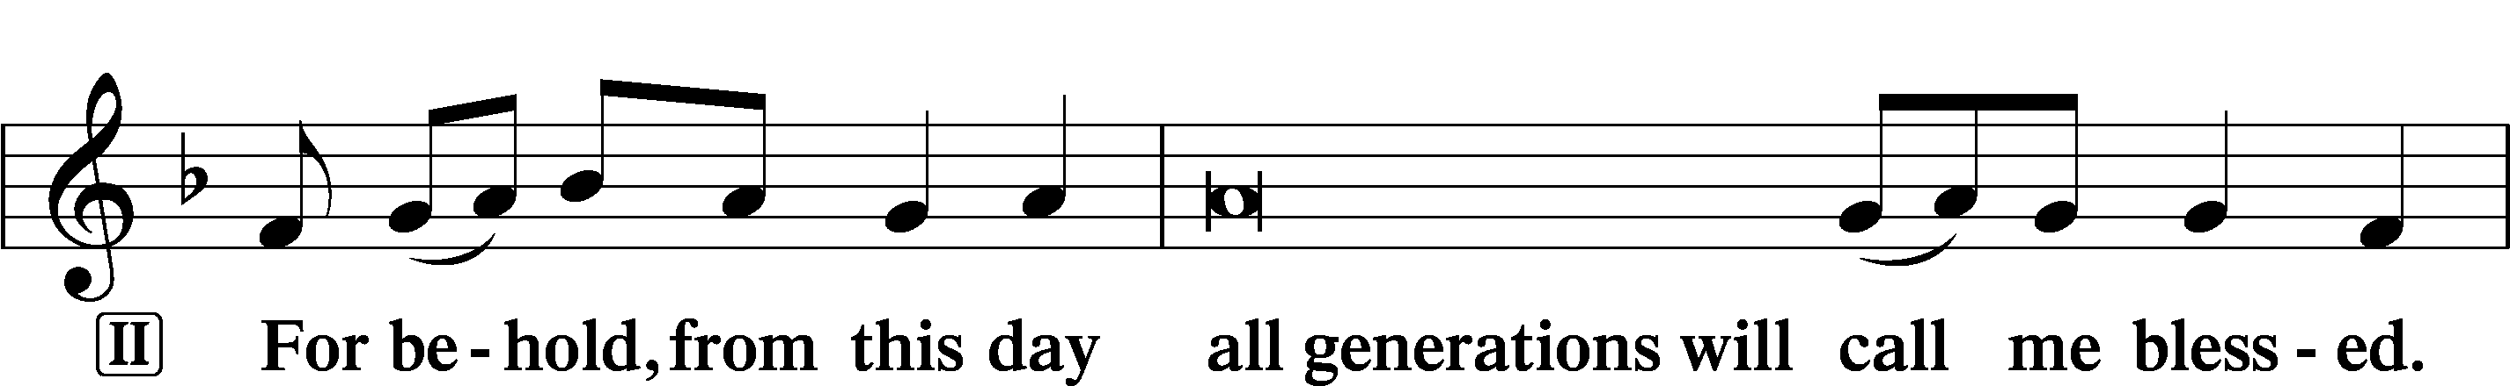
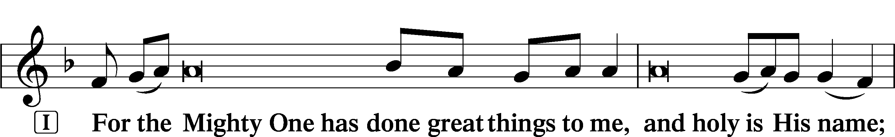
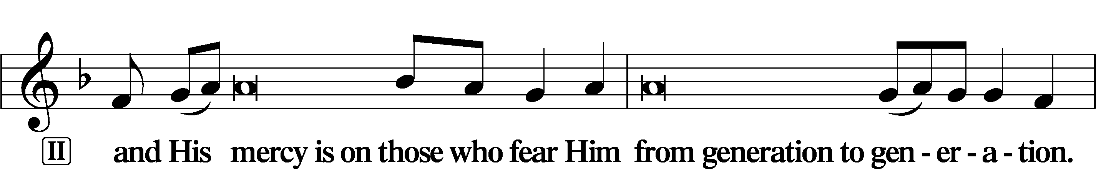
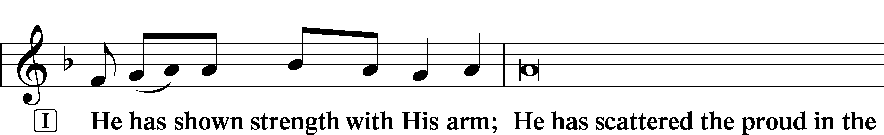
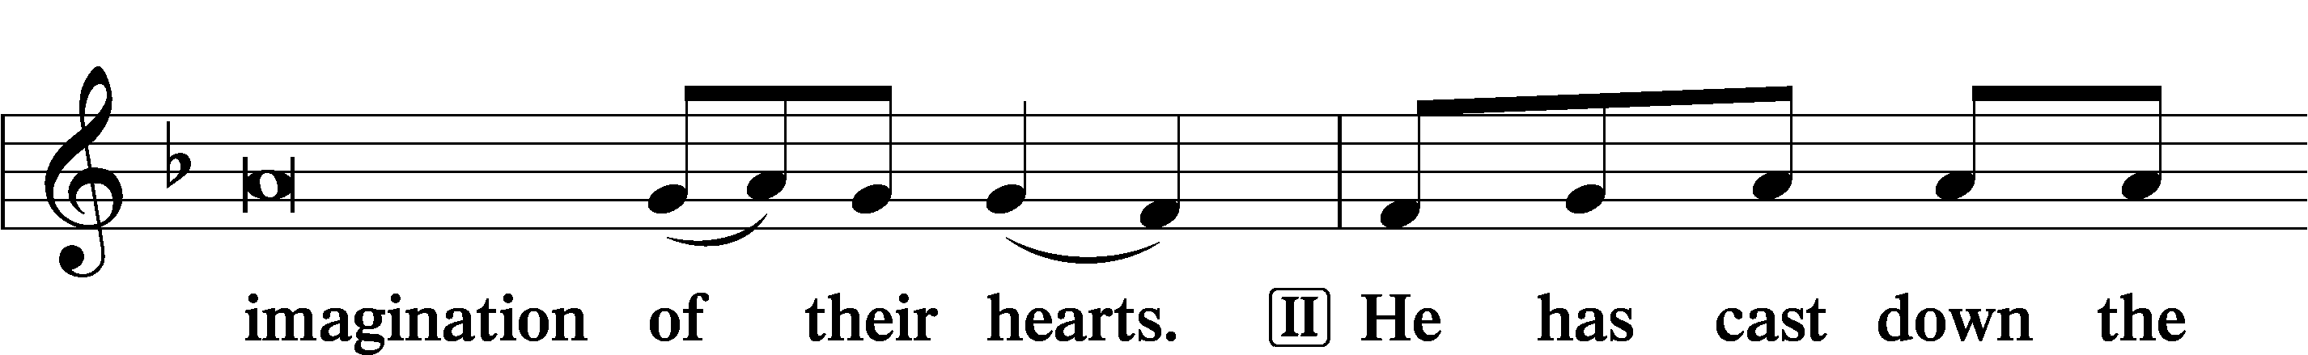
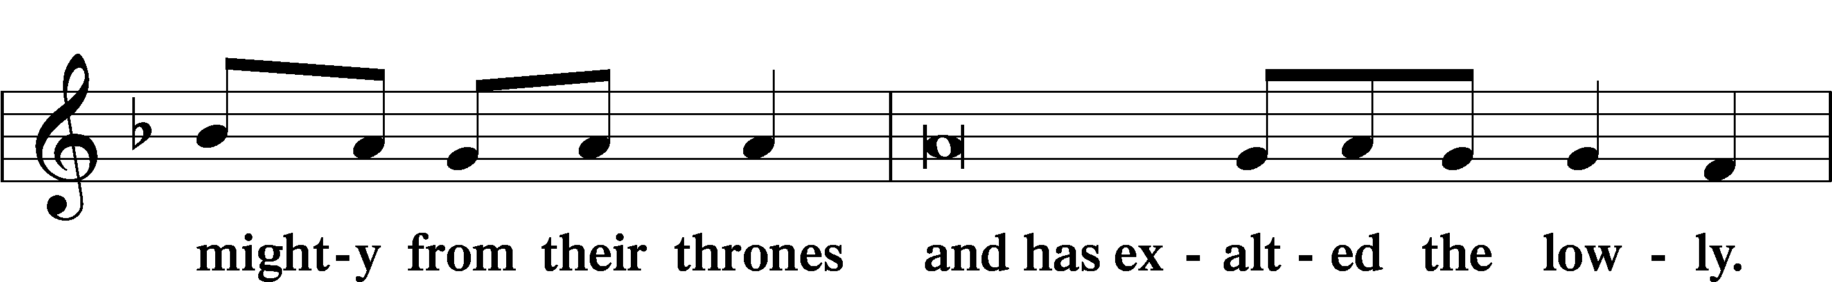
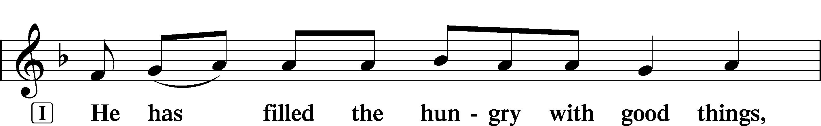
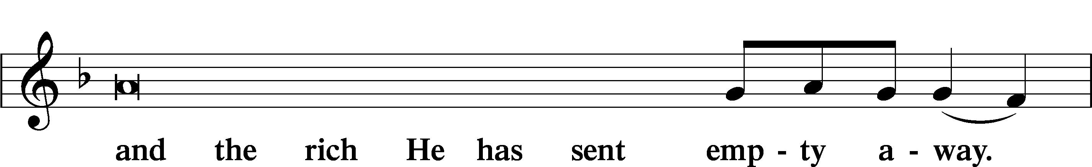
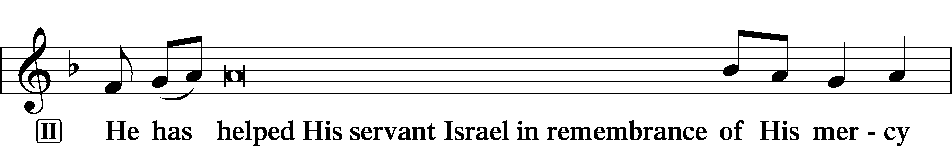
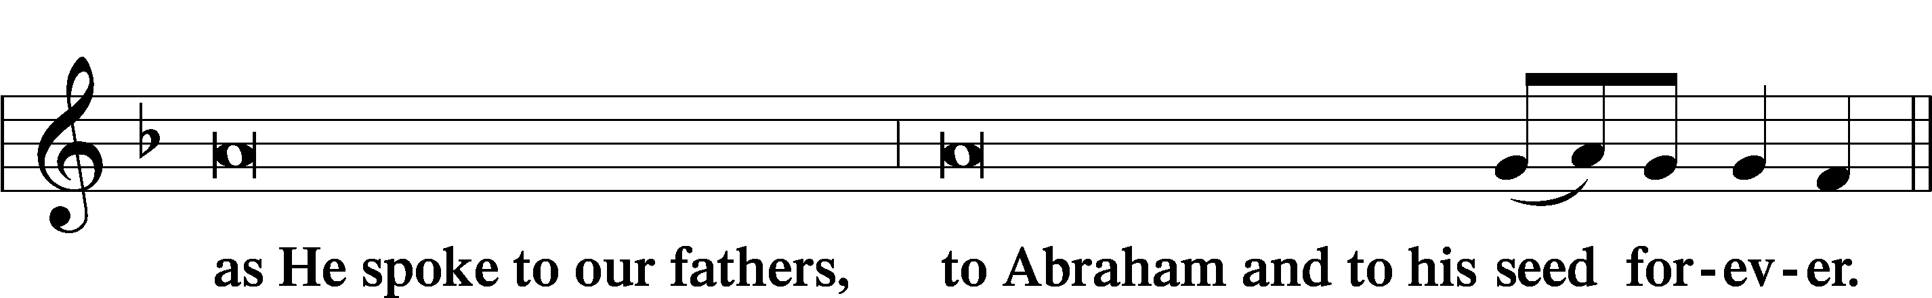
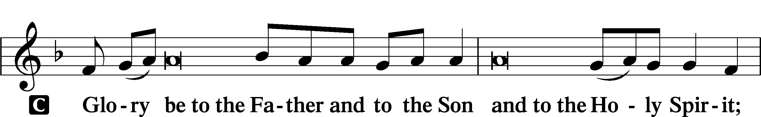
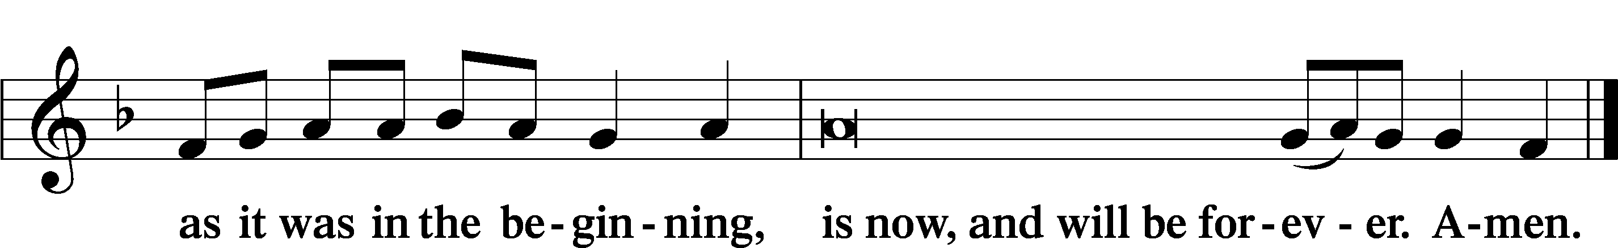

Sit
Prayer
Kneel/Stand

Kyrie LSB 233
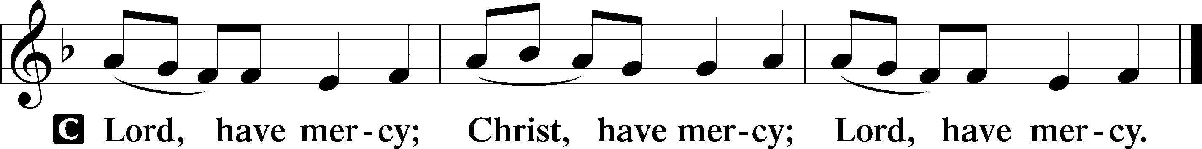

Lord’s Prayer
C Our Father who art in heaven,
hallowed be Thy name,
Thy kingdom come,
Thy will be done on earth
as it is in heaven;
give us this day our daily bread;
and forgive us our trespasses
as we forgive those
who trespass against us;
and lead us not into temptation,
but deliver us from evil.
For Thine is the kingdom
and the power and the glory
forever and ever. Amen.

Collects

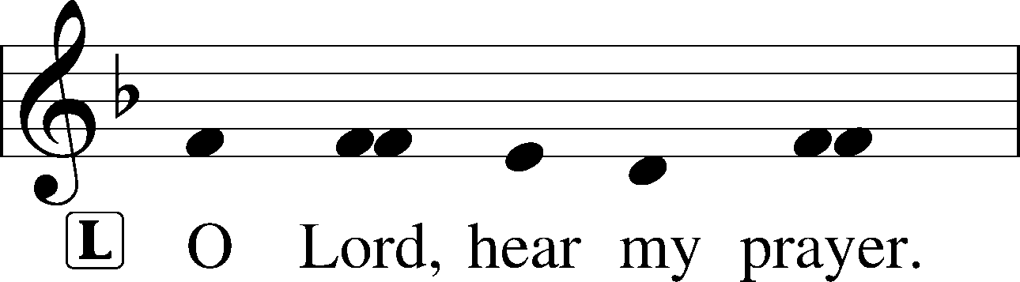
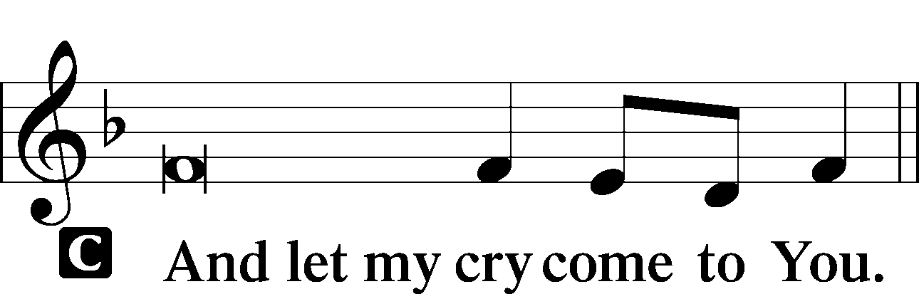

Collect of the Day
P Almighty God, by Your great goodness mercifully look upon Your people that we may be governed and preserved evermore in body and soul; through Jesus Christ, Your Son, our Lord, who lives and reigns with You and the Holy Spirit, one God, now and forever.
Collect for Peace
P O God, from whom come all holy desires, all good counsels, and all just works, give to us, Your servants, that peace which the world cannot give, that our hearts may be set to obey Your commandments and also that we, being defended from the fear of our enemies, may live in peace and quietness; through Jesus Christ, Your Son, our Lord, who lives and reigns with You and the Holy Spirit, one God, now and forever.
C Amen.

Stand
Benedicamus LSB 234
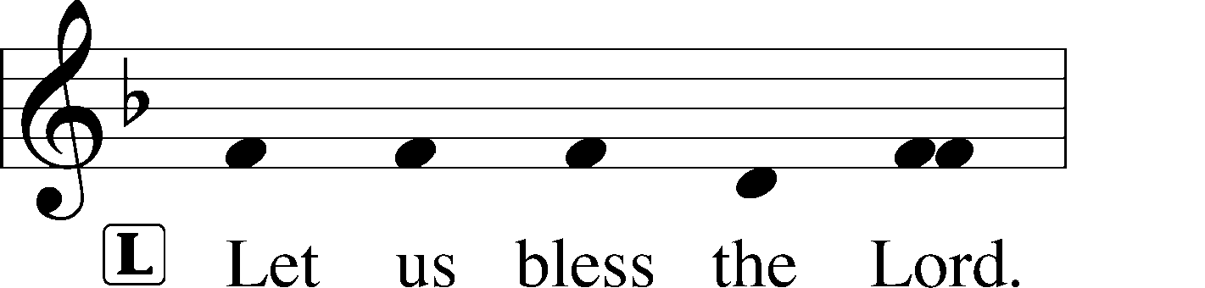
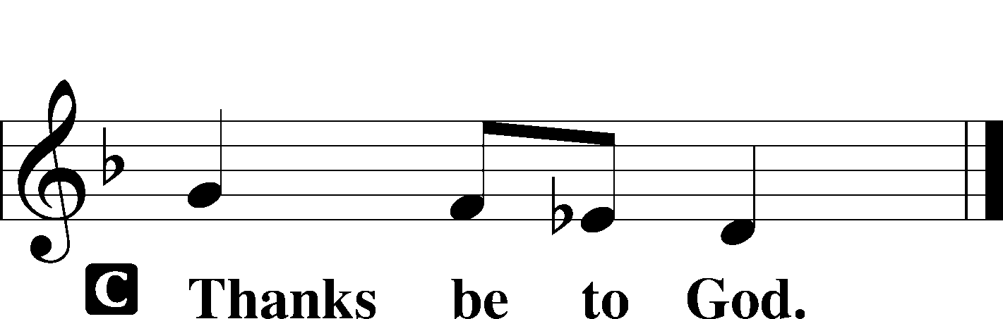

Benediction LSB 234
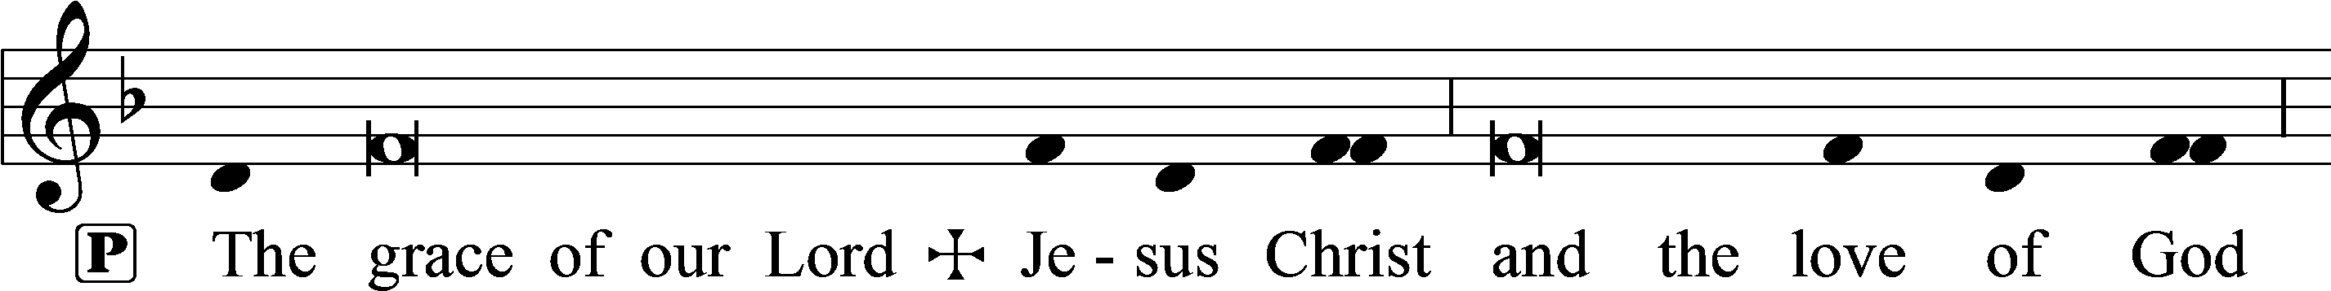
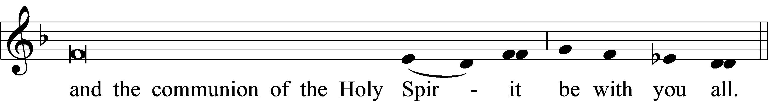

Hymn to Depart: 438 A Lamb Goes Uncomplaining Forth

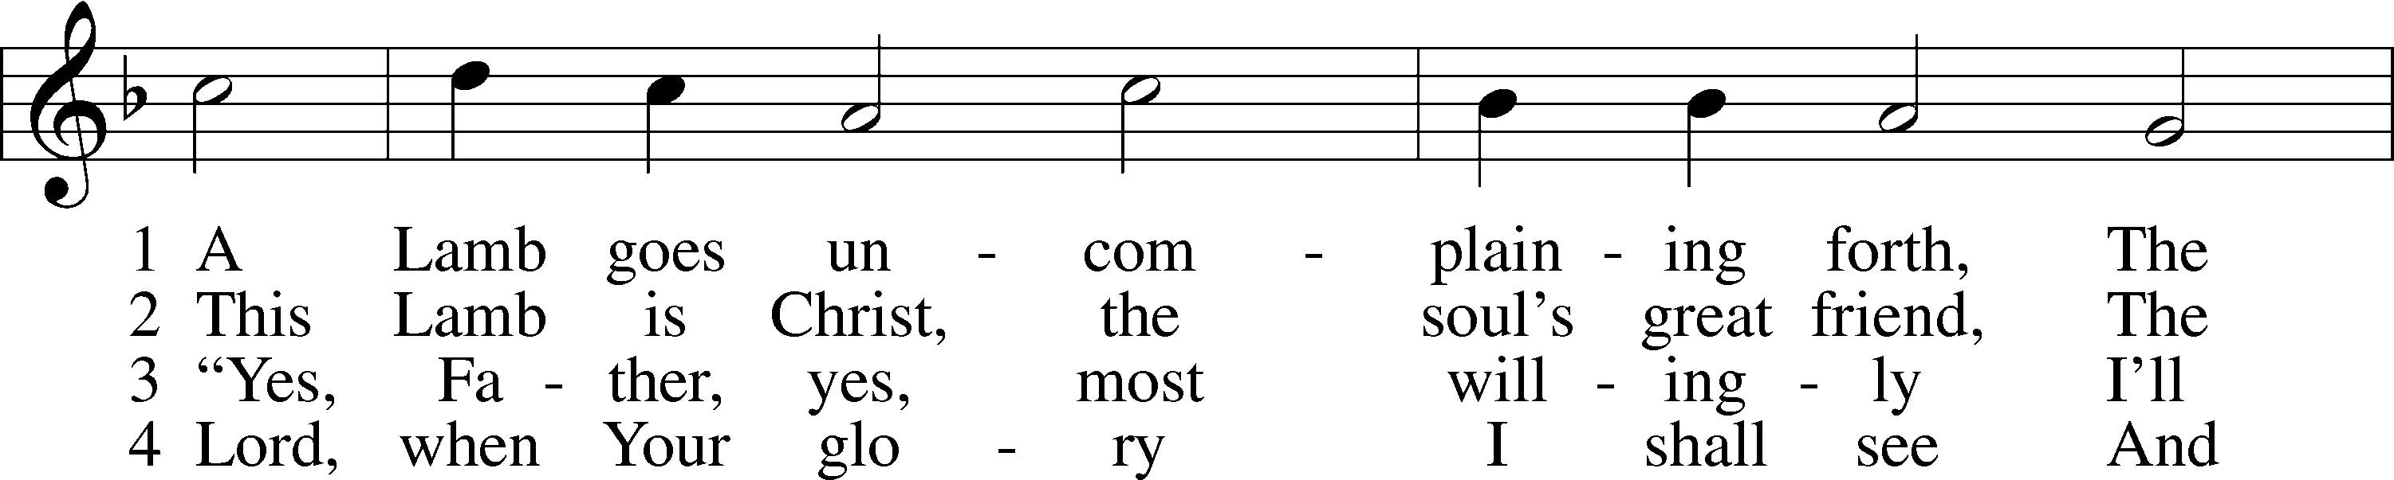
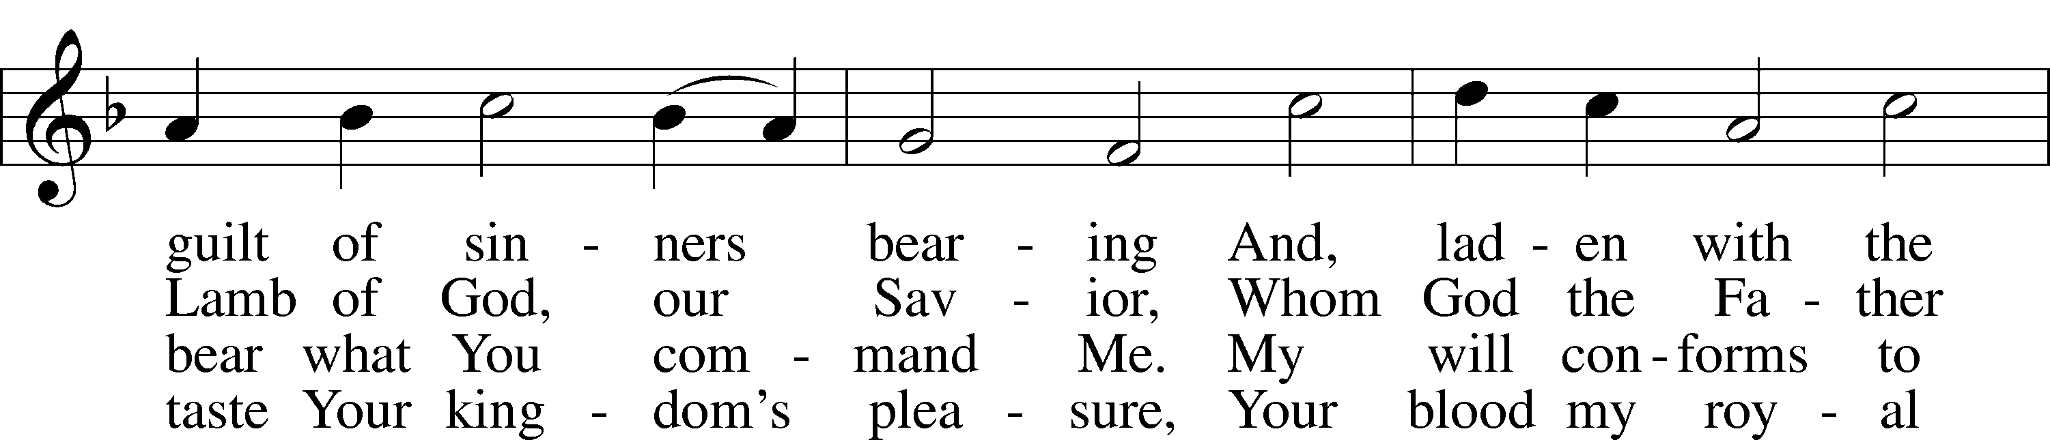
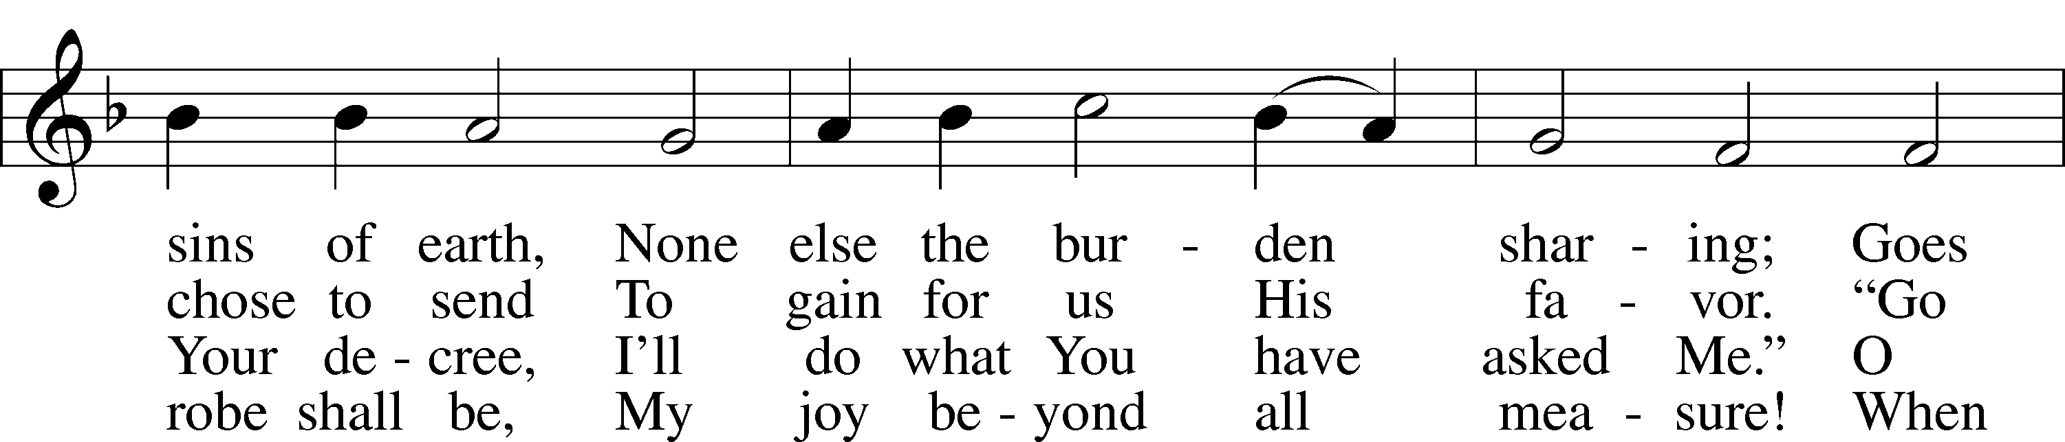
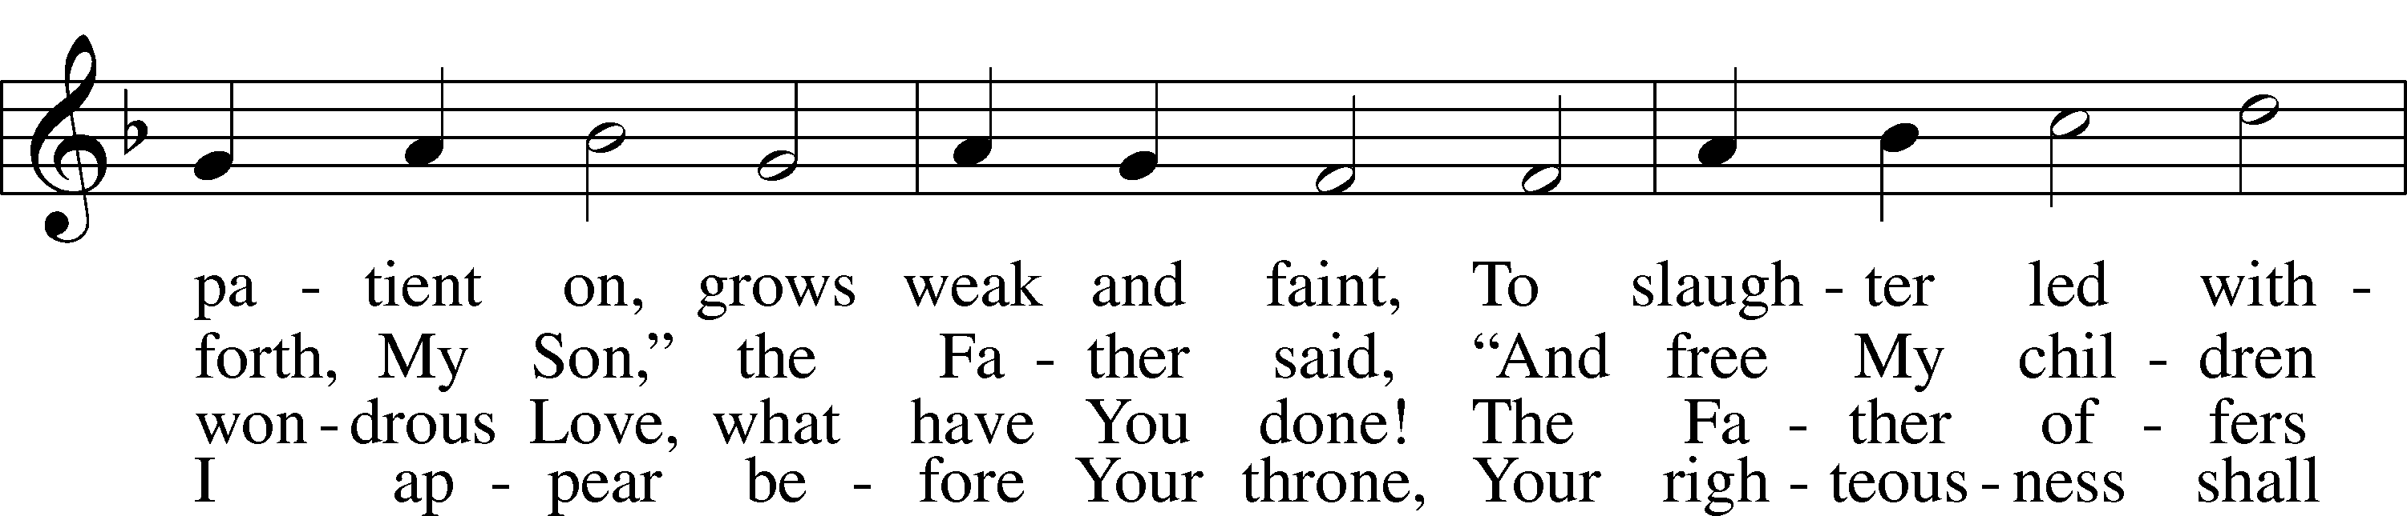
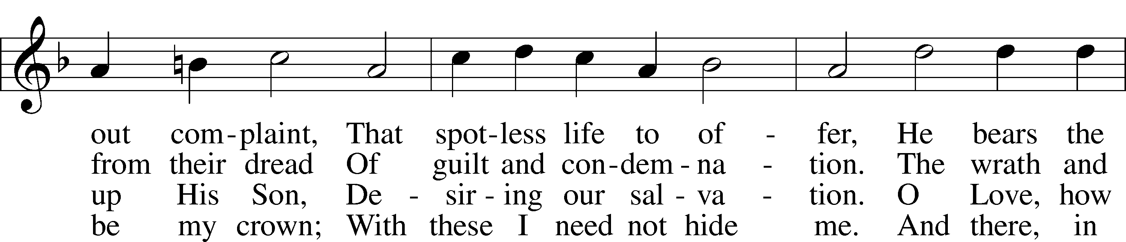
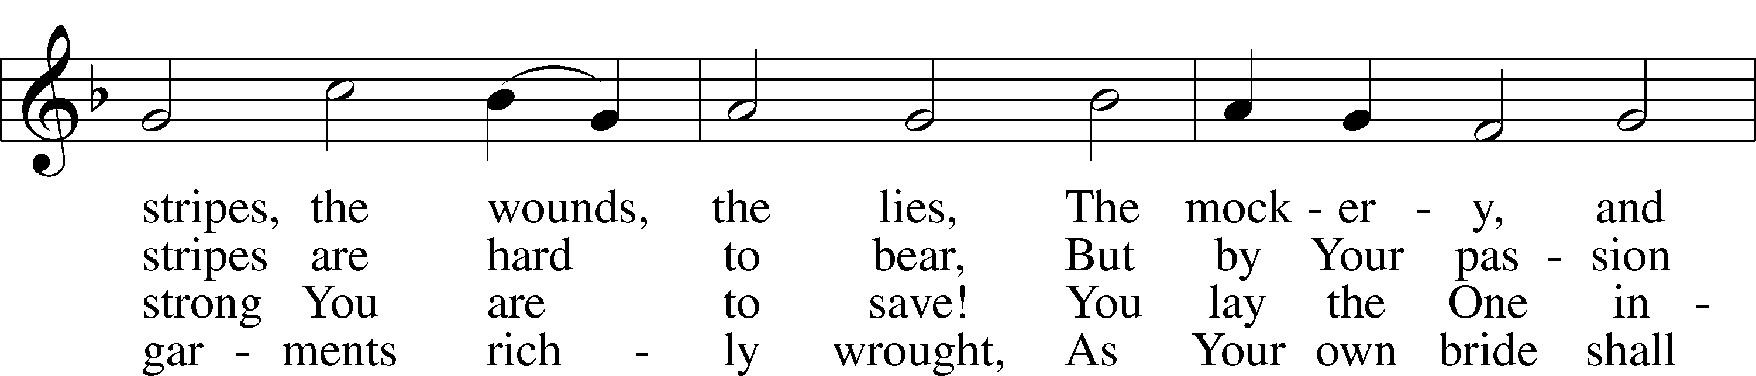
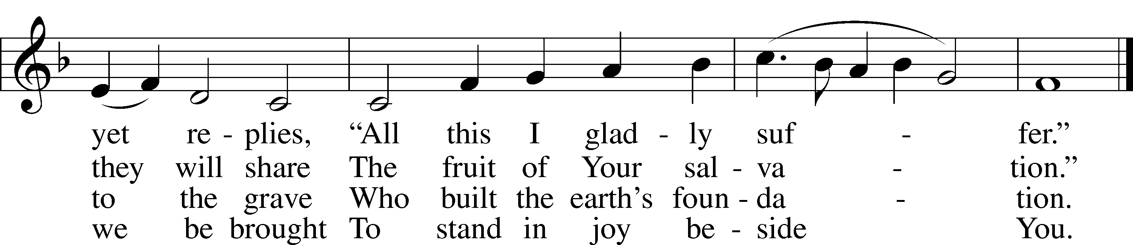

Tune: Public domain
Text: © 1941 Concordia Publishing House. Used by permission: LSB Hymn License no. 110000483

Acknowledgments
Vespers from Lutheran Service Book
Unless otherwise indicated, Scripture quotations are from the ESV® Bible (The Holy Bible, English Standard Version®), copyright © 2001 by Crossway, a publishing ministry of Good News Publishers. Used by permission. All rights reserved.
Created by Lutheran Service Builder © 2018 Concordia Publishing House.

